# How to post complex JSON data to ASP.NET Core

## Introduction

This sample demonstrates how to post complex JSON data to ASP.NET Core.

## Sample prerequisites

* Visual Studio 2017 or above. [[Visual Studio Home Page](https://www.visualstudio.com/)]

## Building the sample

* Open the sample solution “**CSPostComplexJsonASPNETCore.sln**” using Visual Studio.
* Right click the project “**CSPostComplexJsonASPNETCore**” and select Restore Packages.
* Press **F6 Key** or select **Build -> Build Solution** from the menu to build the sample.

## Running the sample

* Open the sample solution using Visual Studio, then press **F5 Key** or **select Debug -> Start Debugging** from the menu.
* When the web application is running, you can see the page in browser.

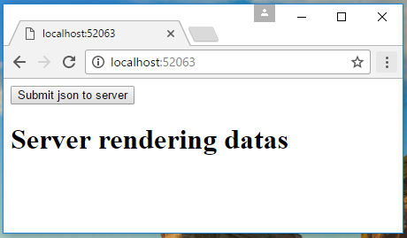

Click the **Submit json to server** button, then the page will send the json data to server using the ajax.

* Server received the data, then rendering received data to page.

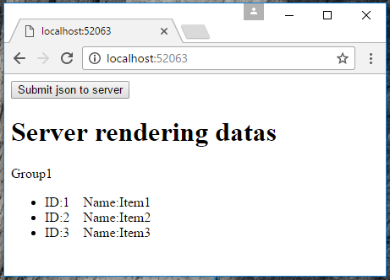

## Using the code

**The Models**

public class ItemGroup

{

public string Name { get; set; }

public IList<GroupItem> Items { get; set; }

}

public class GroupItem

{

public int Id { get; set; }

public string Name { get; set; }

}

**The Front end**

var sendJsonData = {

Name: "Group1",

Items: [

{

Id: 1,

Name: "Item1"

},

{

Id: 2,

Name: "Item2"

},

{

Id: 3,

Name: "Item3"

}

]

};

$("button").click(function () {

$.ajax({

url: "/Home/PostJson",

type: "POST",

contentType: "application/json",

data: JSON.stringify(sendJsonData),

success: function (data) {

if (data.state == 0) {

document.location.reload();

}

}

});

})

**The Controller**

public class HomeController : Controller

{

private static List<ItemGroup> _datas = new List<ItemGroup>();

public IActionResult Index()

{

return View(_datas);

}

[HttpPost]

public JsonResult PostJson([FromBody] ItemGroup data)

{

if (data != null)

{

_datas.Add(data);

}

return Json(new

{

state = 0,

msg = string.Empty

});

}

}

## More information

ASP.NET Core Home page

<https://www.asp.net/core>